|  |  |  |  |  |  |  |  |  |  |  |  |  |  |  |  |  |  |  |  |  |  |  |  |  |  |  |  |  |  |
| --- | --- | --- | --- | --- | --- | --- | --- | --- | --- | --- | --- | --- | --- | --- | --- | --- | --- | --- | --- | --- | --- | --- | --- | --- | --- | --- | --- | --- | --- |
| **INTERSTATE CONTAINER CORPORATION** | | | ***Date:* 04/04/2018** | ***Spec #:*** | | | | | | | | | |  |  |  | ***Design #:* 180141-02_A** | | | | | | | | | | |  |  |
|  |  |  |  |  |
| ***Customer:*** | **DeMet's Candy** |  |  |  |  |  |  |  |  |  |  |  |  |  |  |  |  |  |  |  |  |  |  |  |  |  |  |  |  |
|  |  |  |  |  |  |  |  |  |  |  |  |  |  |  |  |  |  |  |  |  |  |  | ***Cut*** | **140 in.** | |  |  |
|  |  |  |  |  |  |  |  |  |  |  |  |  |  |  |  |  |  |  |  |  |  |  |  |  |
| ***Description:*** | **Polyjoined HSC top - New 9.3oz Box Size** | |  |  |  |  |  |  |  |  |  |  |  |  |  |  |  |  |  |  |  |  |  |  |  |  |
|  |  |  |  |  |  |  |  |  |  |  |  |  |  |  |  |  |  |  |  |  |  | ***Crease*** | **40 in.** | |  |  |
|  |  |  |  |  |  |  |  |  |  |  |  |  |  |  |  |  |  |  |  |  |  |  |  |
| ***Style:* HSC** |  | ***Revision Info:* [A] 04/04/2018:add .25" to L & W AG** | |  |  |  |  |  |  |  |  |  |  |  |  |  |  |  |  |  |  |  |  |  | ***Partial cut*** | **1 in.** | |  |  |
| ***I.D. :* 9 x 8+1/4 x 7+5/8** | | ***Blank size:* 12 x 36+1/2** |  |  |  |  |  |  |  |  |  |  |  |  |  |  |  |  |  |  |  |  |  |  | ***1/4 1/4 perf*** | **34 in.** | |  |  |
|  |  |  |  |  |  |  |  |  |  |  |  |  |  |  |  |  |  |  |  |  |  |  |  |
| ***Board:* 32 B K** |  | ***Combination:* 35HP - 23M - 35HP** | ***Designer:* Alan Groff** |  |  |  |  |  |  |  |  |  |  |  |  |  |  |  |  |  |  |  |  |  |  |  |  |  |  |
|  |  |  |  |  |  |  |  |  |  |  |  |  |  |  |  |  |  |  |  |  |  |  |  |  |  |  |

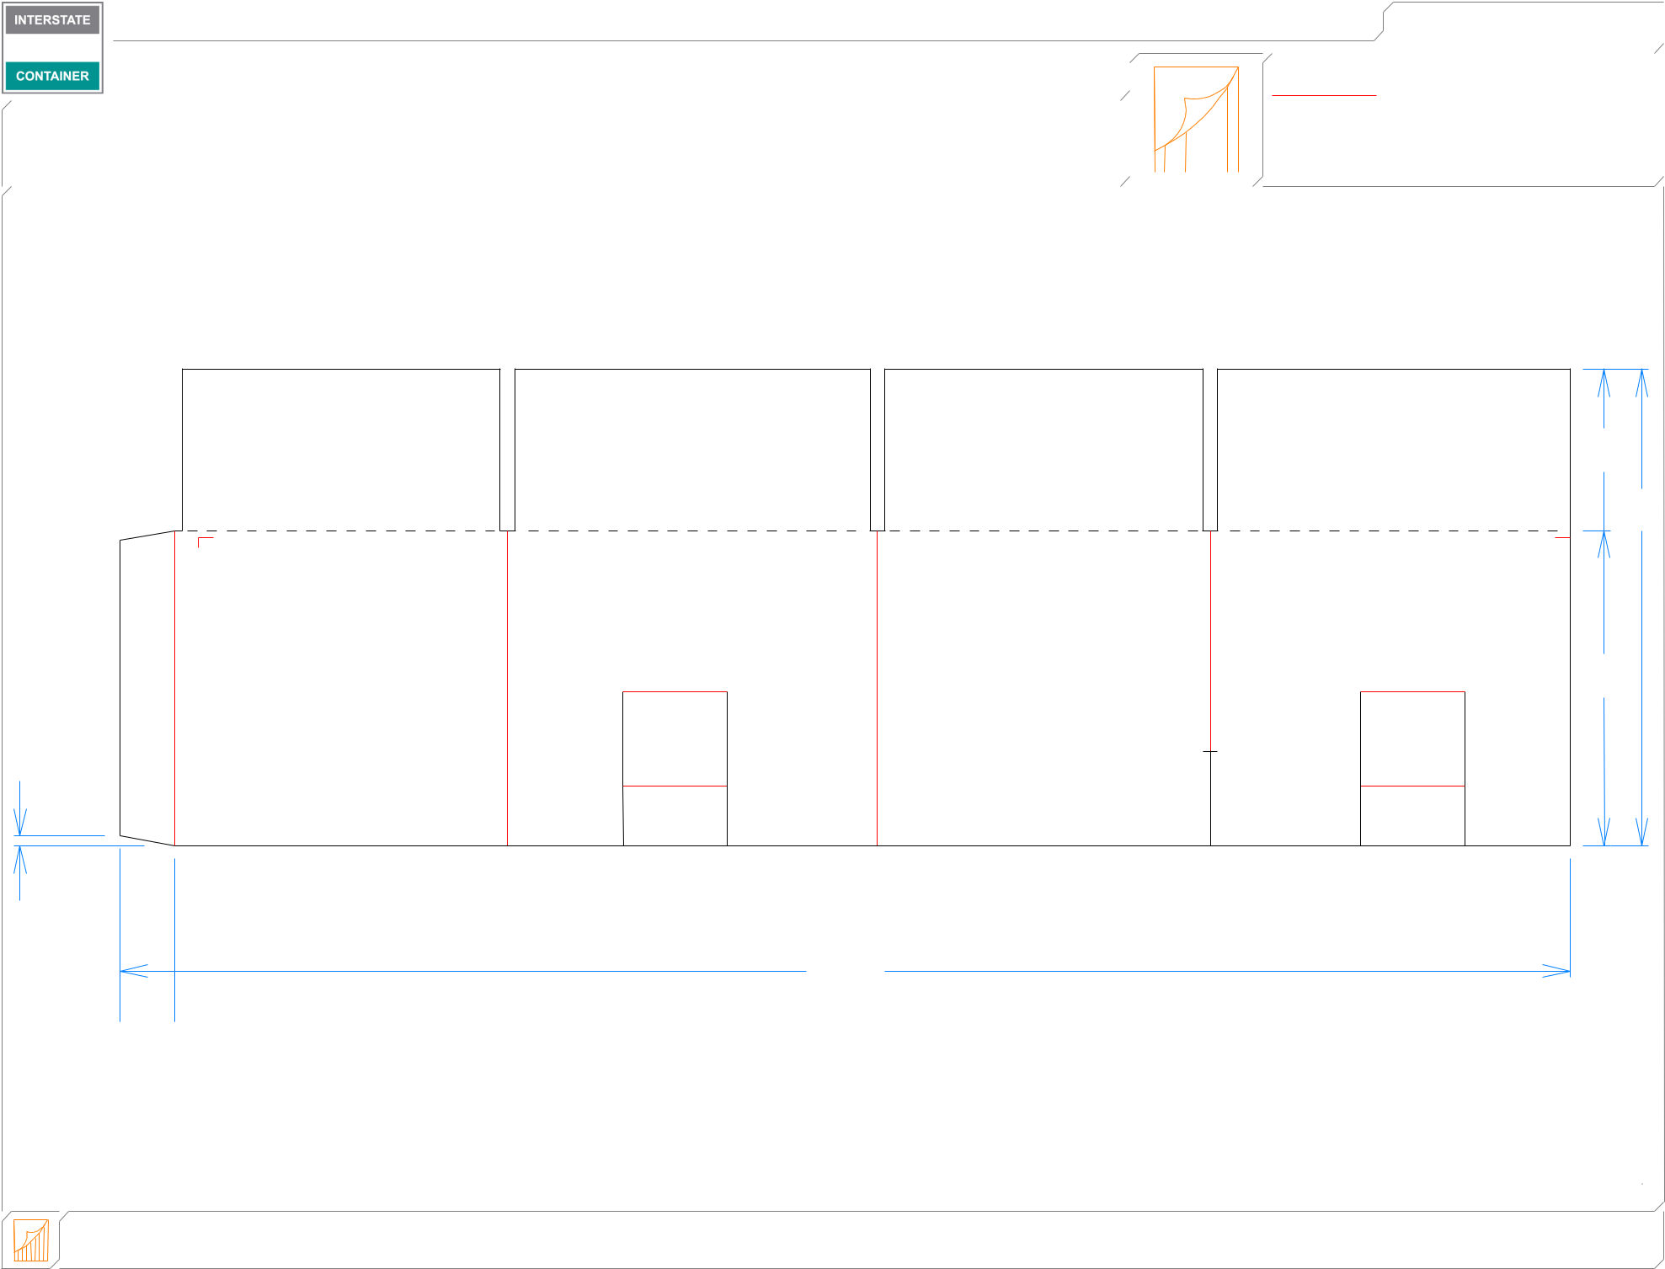

41*/*16

 12

715*/*16

1*/*4

 83*/*8  95*/*16  83*/*8  91*/*16 

361*/*2

 13*/*8 

|  |  |  |  |  |
| --- | --- | --- | --- | --- |
| **inside view** | ***notes:* 8.7oz SUB - 637** | **Polyjoined design** |  |  |
| **Vertical Corrugation** | ***Qty/unit:*** | ***Area - waste:* 2.96 sq. ft** | ***Waste on blank:* 2.6%** | ***Piece weight - waste:* 0.31 lbs./138.61 g** |